***INVOICE REGISTRATION and INVOICE ITEMIZATION MODULE***

***DATA STRUCTURE***

***Purchase invoice is a bill for matterials (or services) sold. Invoices can be issued in paper or electronic form. Most important information on the invoice is*** *sellers name****, (****supplier),invoice number, items sold (matterials), prices (subtotal cost), discounts, taxes, and total cost****. These information is captured in Purchase Invoice table.***

|  |  |  |  |
| --- | --- | --- | --- |
| **Purchase Invoice** - UPDATED 03/03/2016 | | |  |
| PK | IDPurchase Invoice |  |  |
|  | IDsupplier | FK |  |
|  | Date & Time |  | date |
|  | **Invoice Number -** new |  | text |
|  | Subtotal - new |  | real |
|  | Shipping - new |  | real |
|  | Packaging - new |  | real |
|  | Taxes - new |  | real |
|  | Discount - new |  | real |
|  | total value actual |  | real |
|  | Note |  | text |
|  | Invoice Document Link |  | text |

***Purchase Invoice Table to be altered to accommodate new fields:*** Invoice Number, Subtotal, Shipping, Packaging and Taxes.

***Since Invoice can cover expenses for more than one type of material, supplies or services itemization if necessary to properly assign final cost to individual items and calculate unit cost. This process is to be performed by user and end result(s) is stores in Invoice Items table***

New Table:

|  |  |  |  |
| --- | --- | --- | --- |
| **Invoice Items** - UPDATED 03/03/2016 | | | |
| PK | Invoice Item ID |  |  |
|  | Purchase Invoice ID | FK |  |
|  | Material Id | FK |  |
|  | Quantity |  | text |
|  | Subtotal |  | real |
|  | Shipping |  | real |
|  | Packaging |  | real |
|  | Taxes |  | real |
|  | Discount |  | real |
|  | Unit Cost |  | real |
|  | Total |  | real |
|  |  |  |  |

***UI, BUSINESS LOGIC and RULES***

1.To view list of existing invoices

***User navigates to Warehouse*** 🡪 ***Invoices tab. Under “Invoice” Tab user can pick from “Invoice List “ and “Register New Invoice”.***

***Under “Invoice List” tab user should be able to see list of previously entered Purchase Invoices in descending order by the date( from current to past(earliest)).***

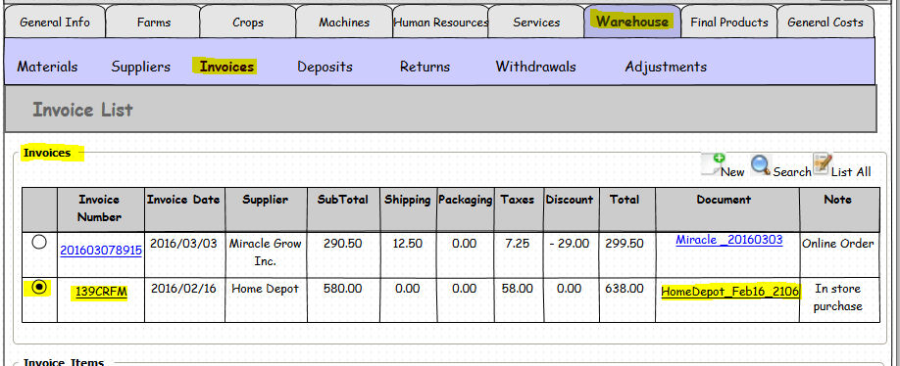*(updated)

Invoice Items form below Invoice List will remain empty until one of the invoices doesn’t get selected (radio button next to it activated).

User should be able to view and edit invoice details by clicking on Invoice Number hyperlink:

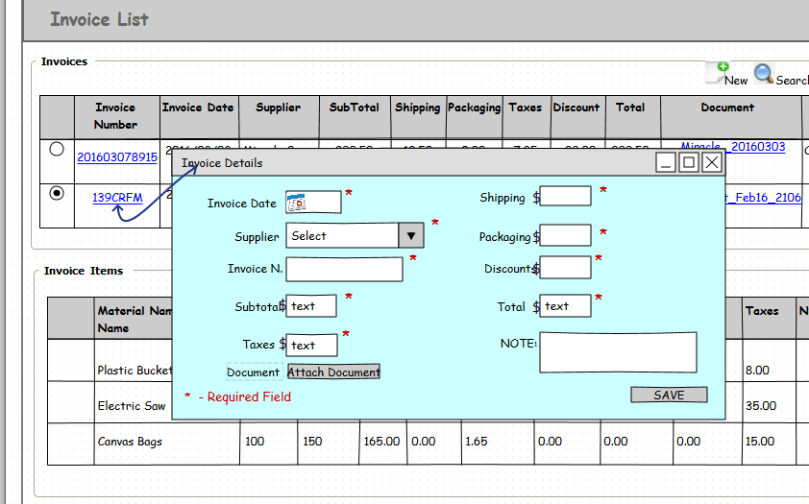

2. Invoice Search

*To locate Invoice record user should be able to click on the “Search” icon and search by* ***Supplier, Invoice Date Range and Invoice Number***

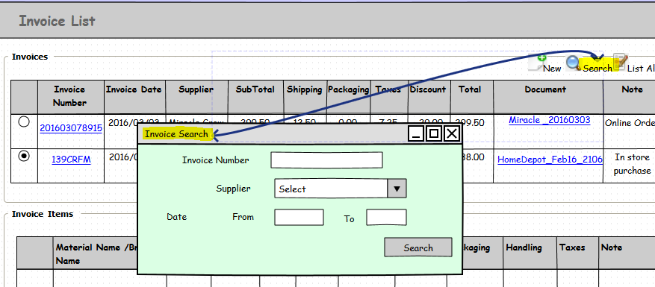

New invoice registration

1. ***User clicks on “NEW”. System opens new screen with new invoice entry form.(****Optionaly**User**can access “New Invoice” screen by selecting*  ***“Register New Invoice”*** *from* ***Invoice*** *sub- menu****)***

***Fields on the form:***  Invoice Date*, Supplier*, Invoice Number*, Subtotal*, Taxes*, Shipping*, Packaging Discounts*, Total*, Note, “Attach Document” is a button with upload functionality.

Required fields marked with asterisk *.

1. Unit cost in each line is auto-calculated field = Total / Number of units
2. Discount to be shown in the brackets or as negative. Example : (4.00) or -4.00

*Required Field

**____________________________________________________________________________________**

*UPDATED

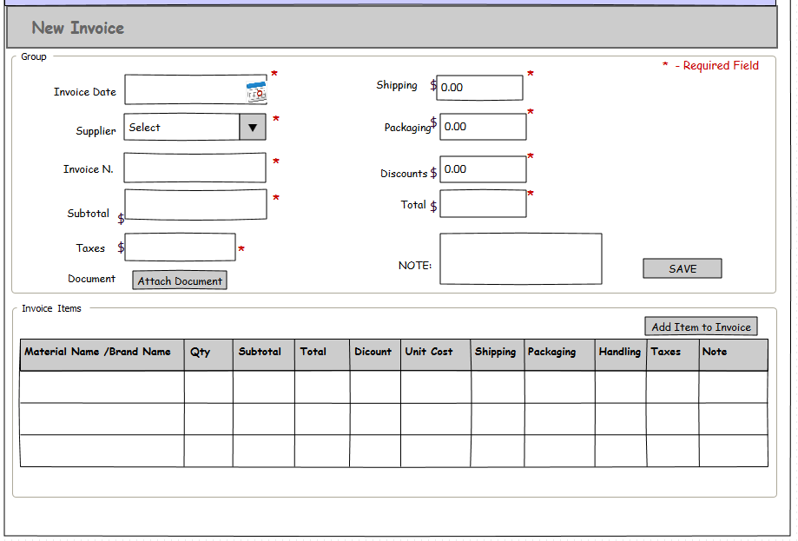

1. ***User enters information and clicks on SAVE.*** Required Fields are: ***Invoice Date, Supplier,* *Subtotal, and Total***
2. ***Before saving a record, system validates Invoice number and Supplier combination being unique.***

***If same invoice number has been found for selected supplier system should emit error:***

***Duplicate Invoice: Same invoice number exists for selected Supplier.***

1. ***Once new invoice has been added, user can select radio button to activate “Invoice Items” form below and “Add Invoice Items” button functionality.***
2. ***User clicks on “Attach Document” to upload related file.***
3. ***User can add invoice items to the invoice in the “Invoice Items” form.***
4. ***New Invoice Items are added to “Invoice Items” form.***

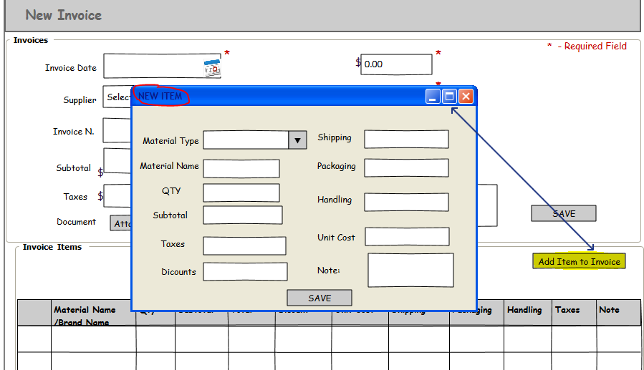

Edit and Add Invoice Items

***User can edit Invoice information and Invoice Items if needed by clicking on “Edit” button.***

***Form similar to new invoice opens up.***

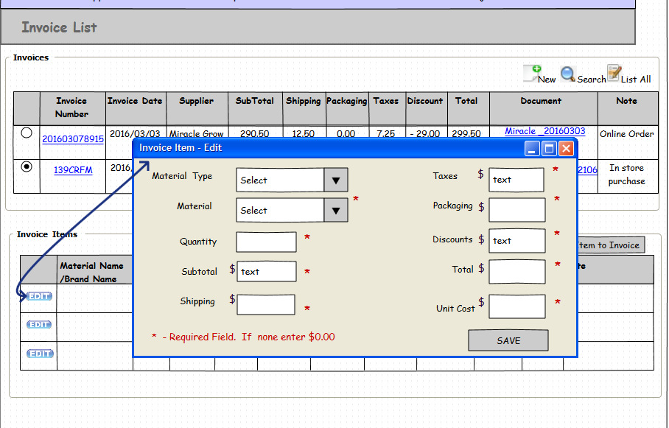

***To enter new invoice items click on “Add Invoice Items” button in the Invoice Items* form *below.***

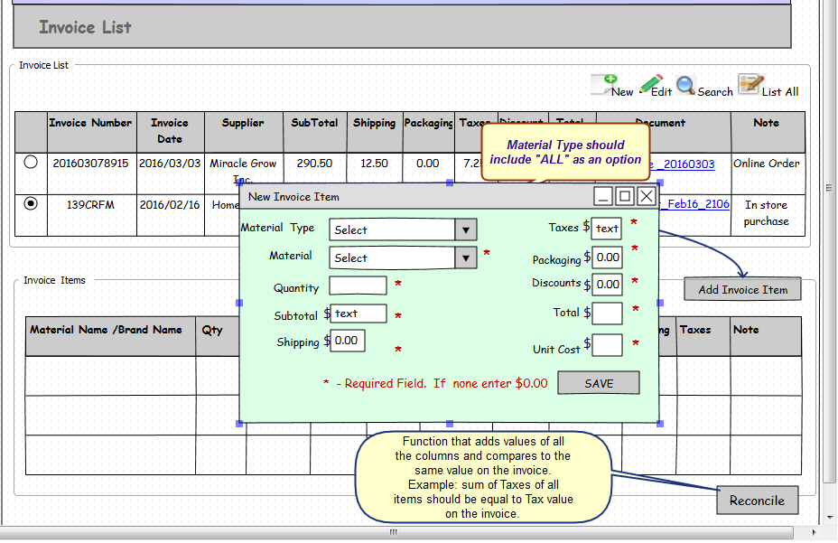

1. ***User Selects Material Type***

**Note**: There are two possible ways the user can find required material:

**a**. Through selecting Material Type and thus narrowing Materials list

**b**. Thourgh selecting ***“ALL”*** as material type and thus making Material List to show all the records in Materials table.

1. ***User locates Materials – required Field***
2. ***User enters Quantity - required Field* ≠ *0***

***Initial Defualt values for Discount,) Packaging and Shipping are “0.00”***

1. ***User enters Subtotal - required Field* ≠ *0***
2. ***User enters Shipping - required Field, can be = 0***
3. ***User enters Taxes - required Field, can be = 0***
4. ***User enters Packaging - required Field, can be = 0***
5. ***User enters Discount - required Field, can be = 0***
6. ***User enters Total - required Field* ≠ *0***
7. ***User calculates and enters Unit Cost -*** ***required Field* ≠ *0***
8. ***“SAVE” button –*** saves the record and displays is in the Invoice Items form.

Reconcile Invoice Items

***“Reconcile” button –*** *adds up values of* ***Subtotal, Shipping, Taxes, Packaging, Discount and Total*** *from*

*Invoice Items form and matches it with the value on the Invoice.   
For Example: Invoice total is 100, shipping -10 and subtotal -90. (Let’s assume that there is no packaging, tax or shipping fees). Invoice Item A has subtotal 49, total 60 and shipping fee 11*

*Invoice Item B has subtotal 35, shipping 5 and total 40. If user forgets to enter 5 for shipping or made a mistake invoice won’t reconcile and message appears: “Total Shipping Cost didn’t Match Invoice”.*

*Similarly, messages will appear for each category (Discount, Total, Subtotal, Packaging, Taxes).*